Welcome to _TECHQUEST

Thanks for opening this file this means that I’ve got your attention and I hope the project will do also :D.

Here I will explain to you what is really going on inside this project

1st: First make sure you’ve entered the correct form that is illustrated in the placeholder otherwise it will return not valid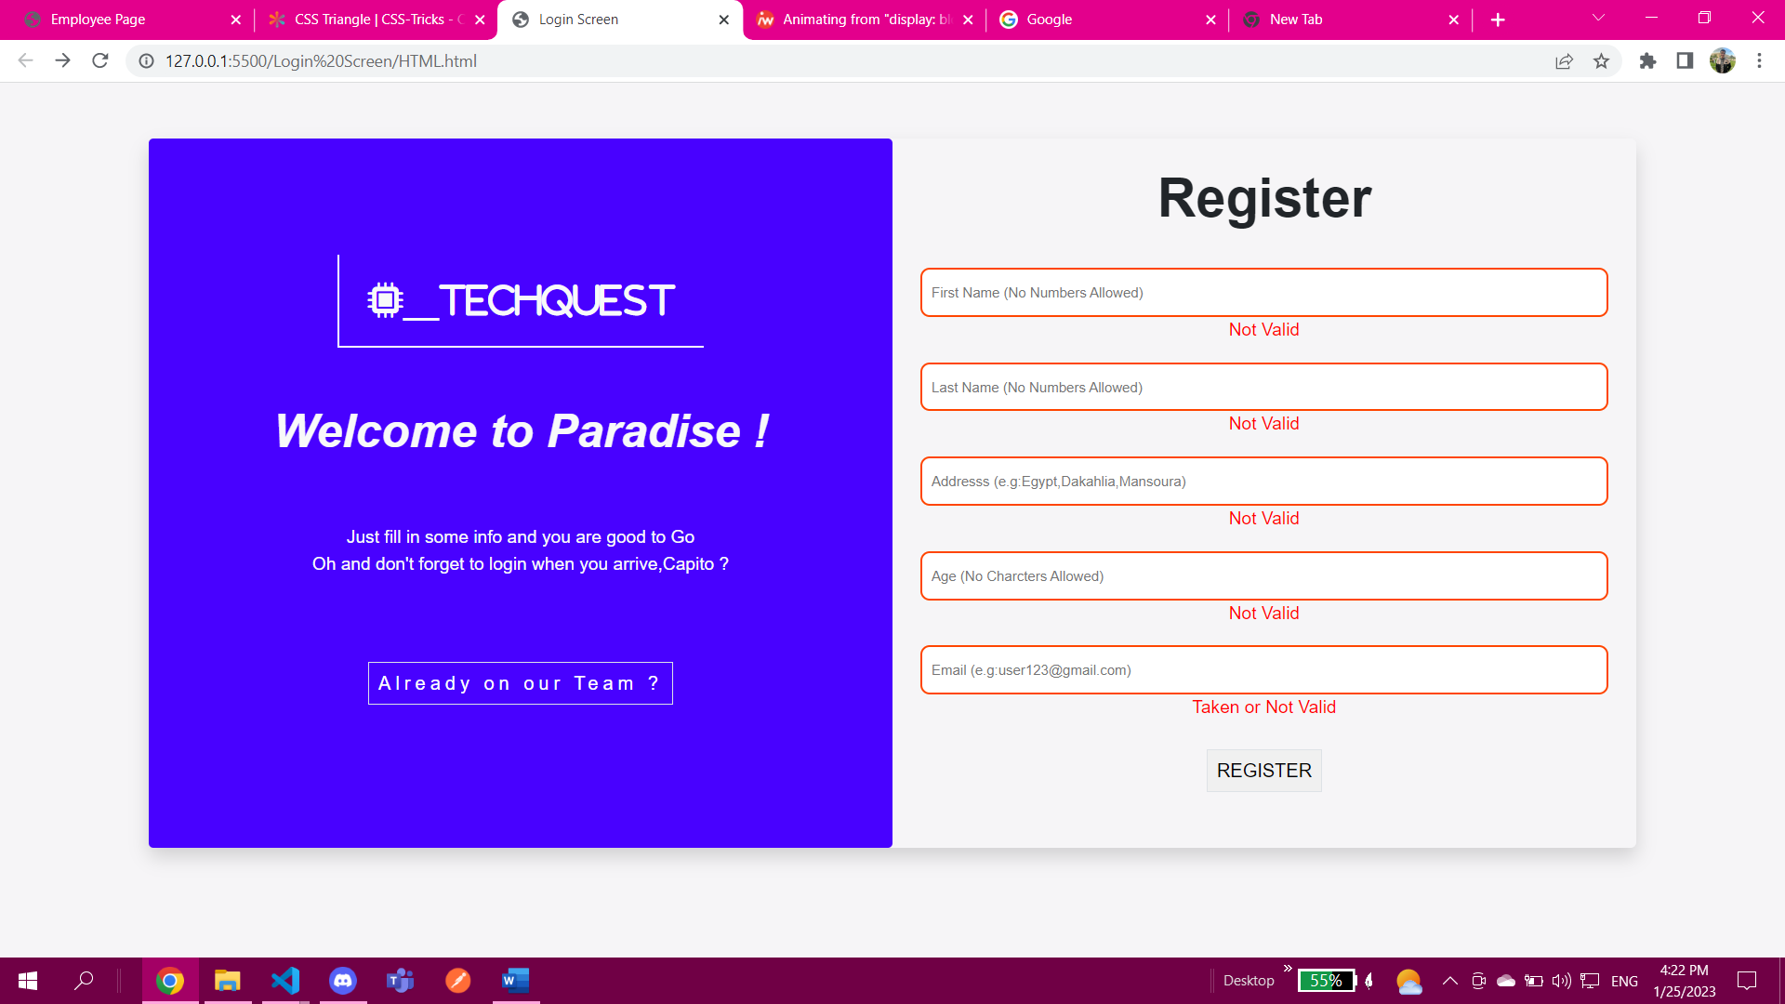

This is what it looks like when you enter the correct value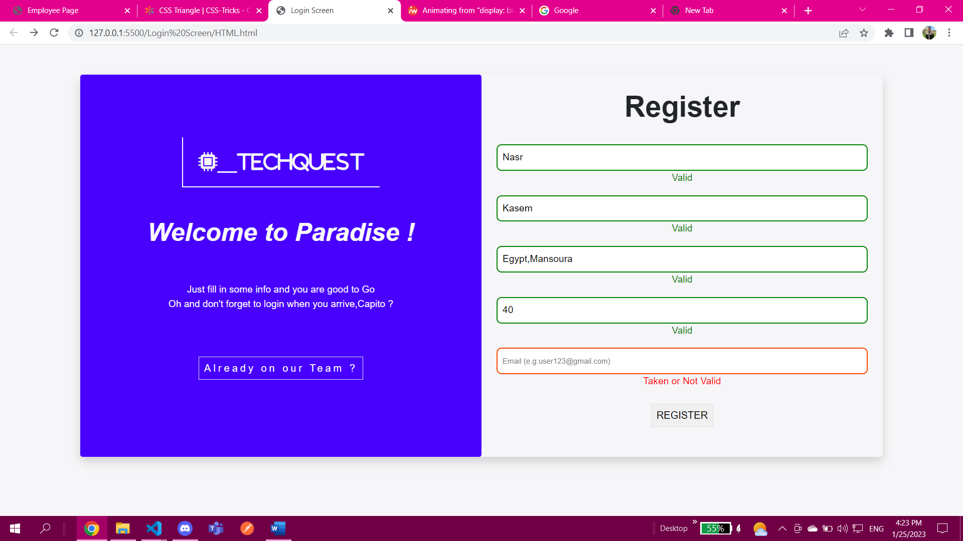of course here it was my intention to leave the email blank to show you that the validation is working

2nd:after registration you as an admin whose user name is : 1QrsPciO will have to login and confirm the registration process

3rd: 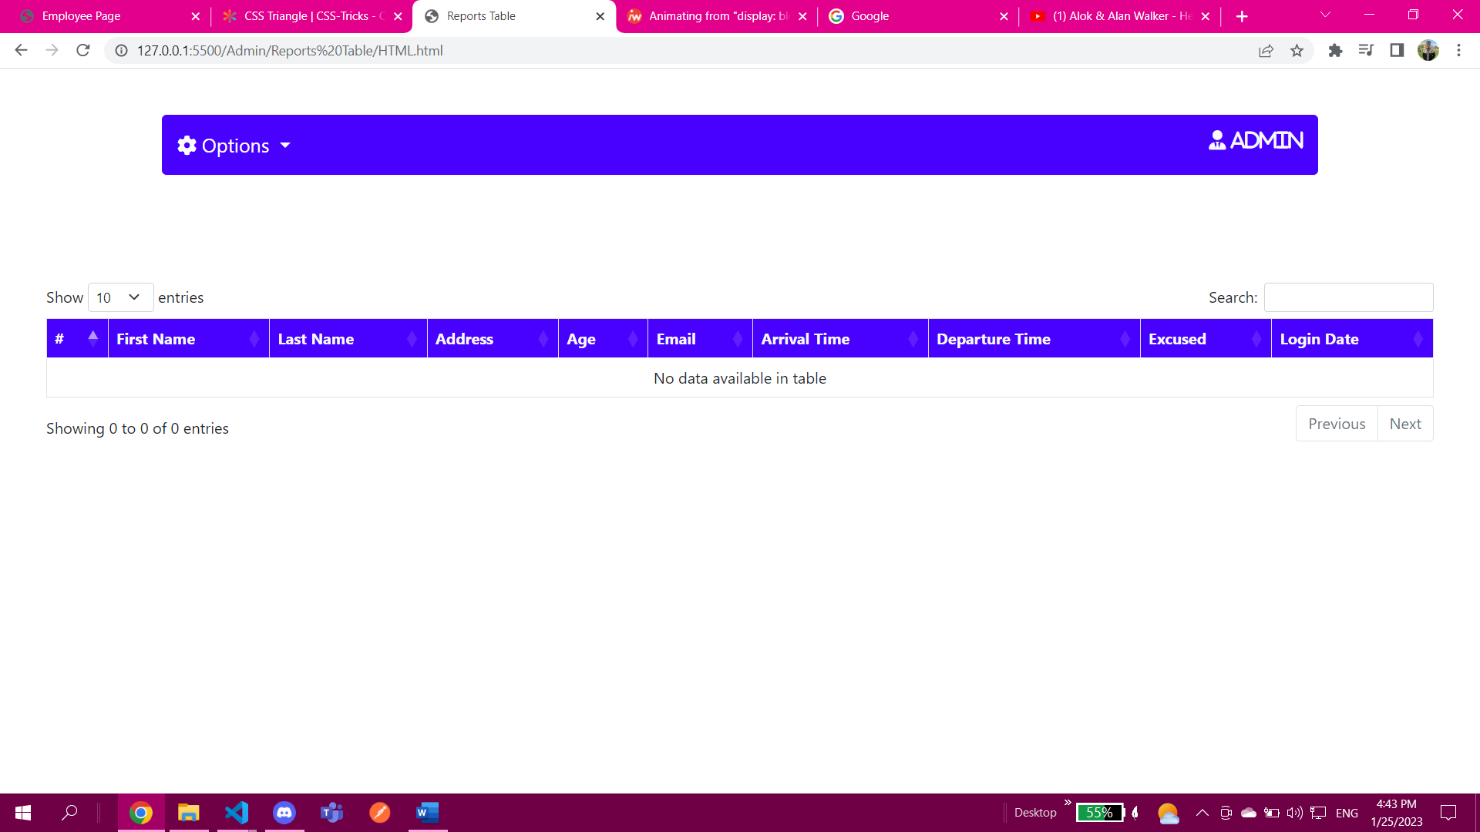

Here after signing in as admin you will be in the reports tab to change it go to options and select new employee management

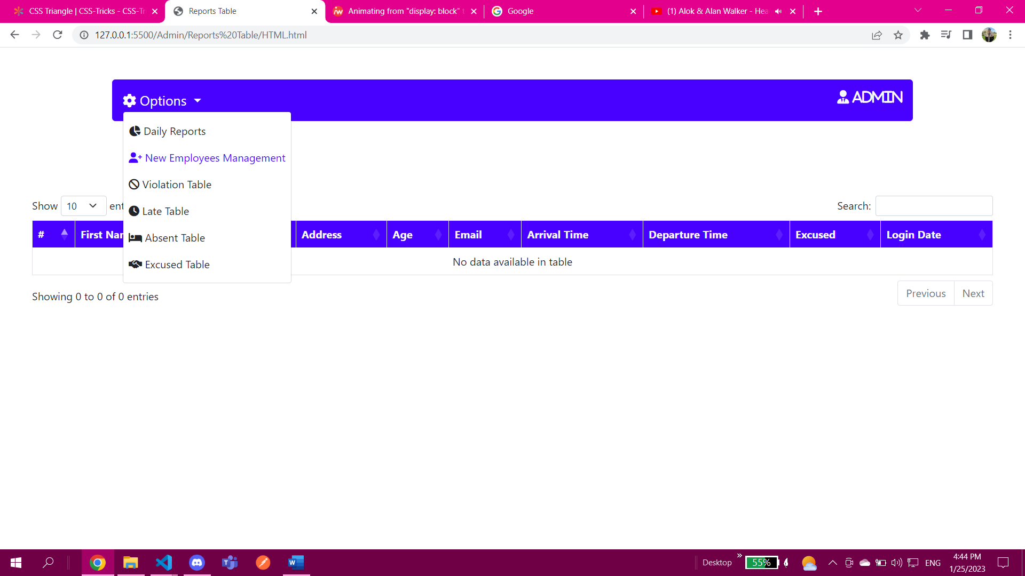

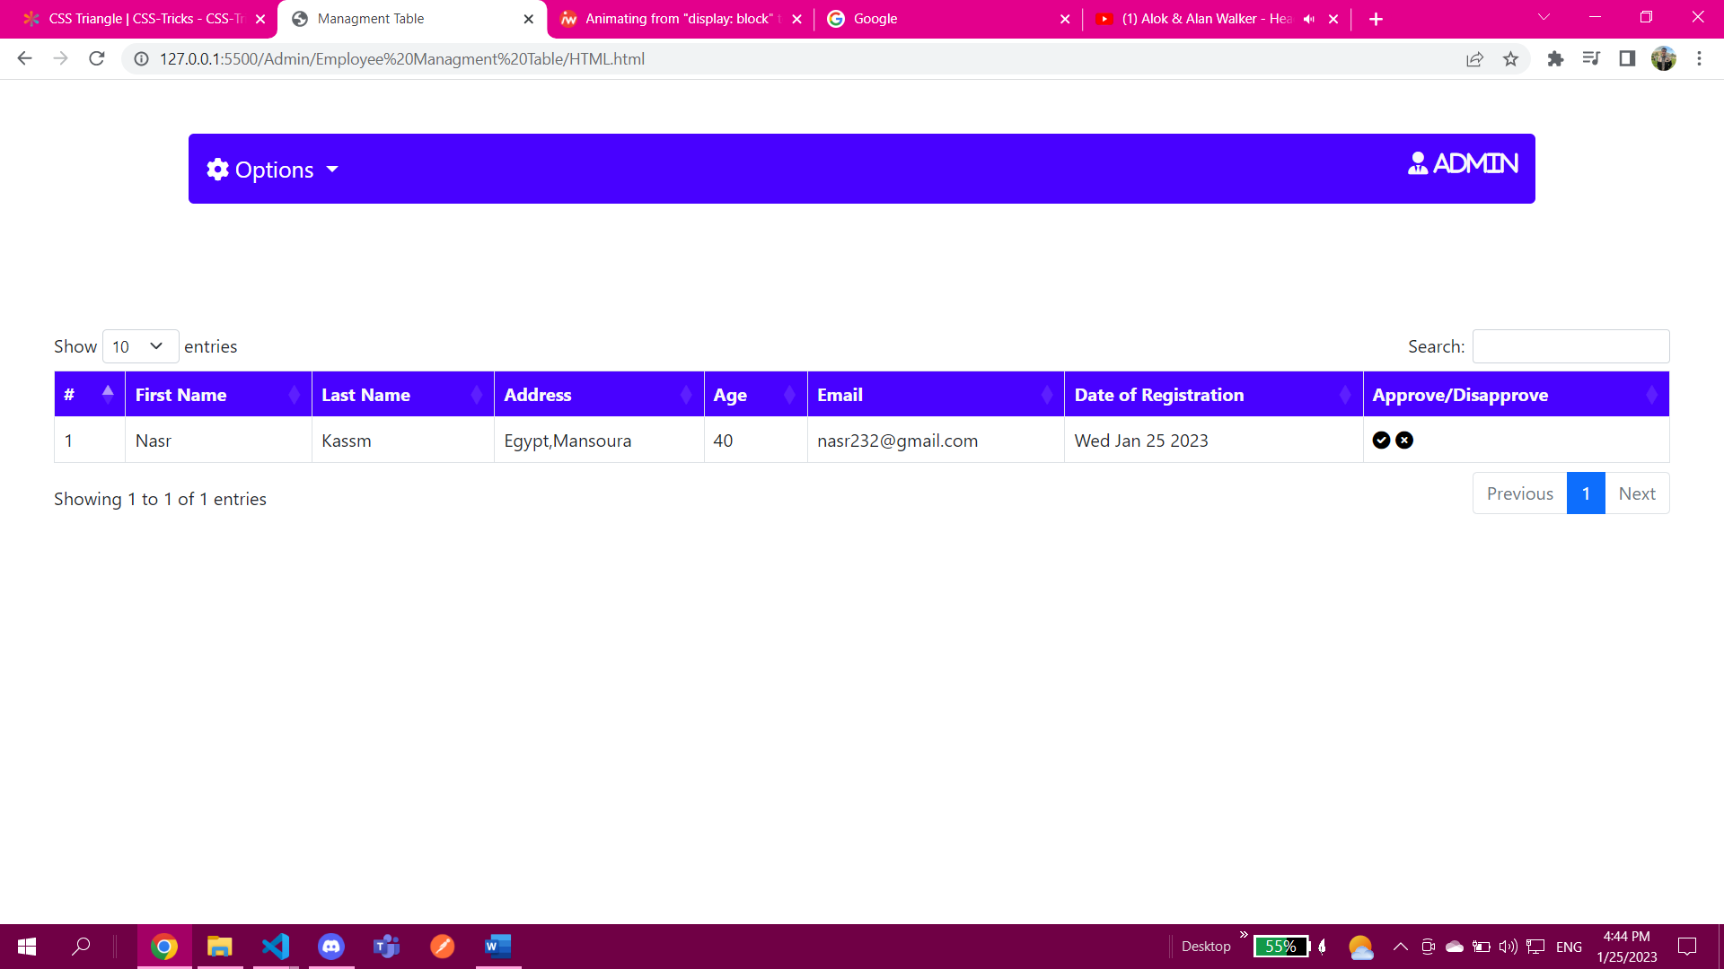

You as an admin has the authorization to make the decision either to approve this new employee or disapprove

Lets say you approved then this employee will be save in an array called approved

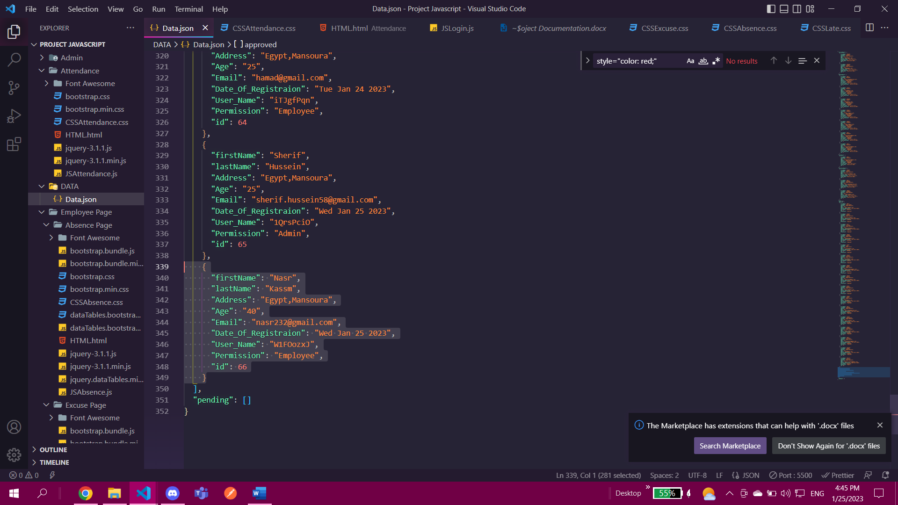

Now of course this user name should be sent to his email then with it he can login in using it

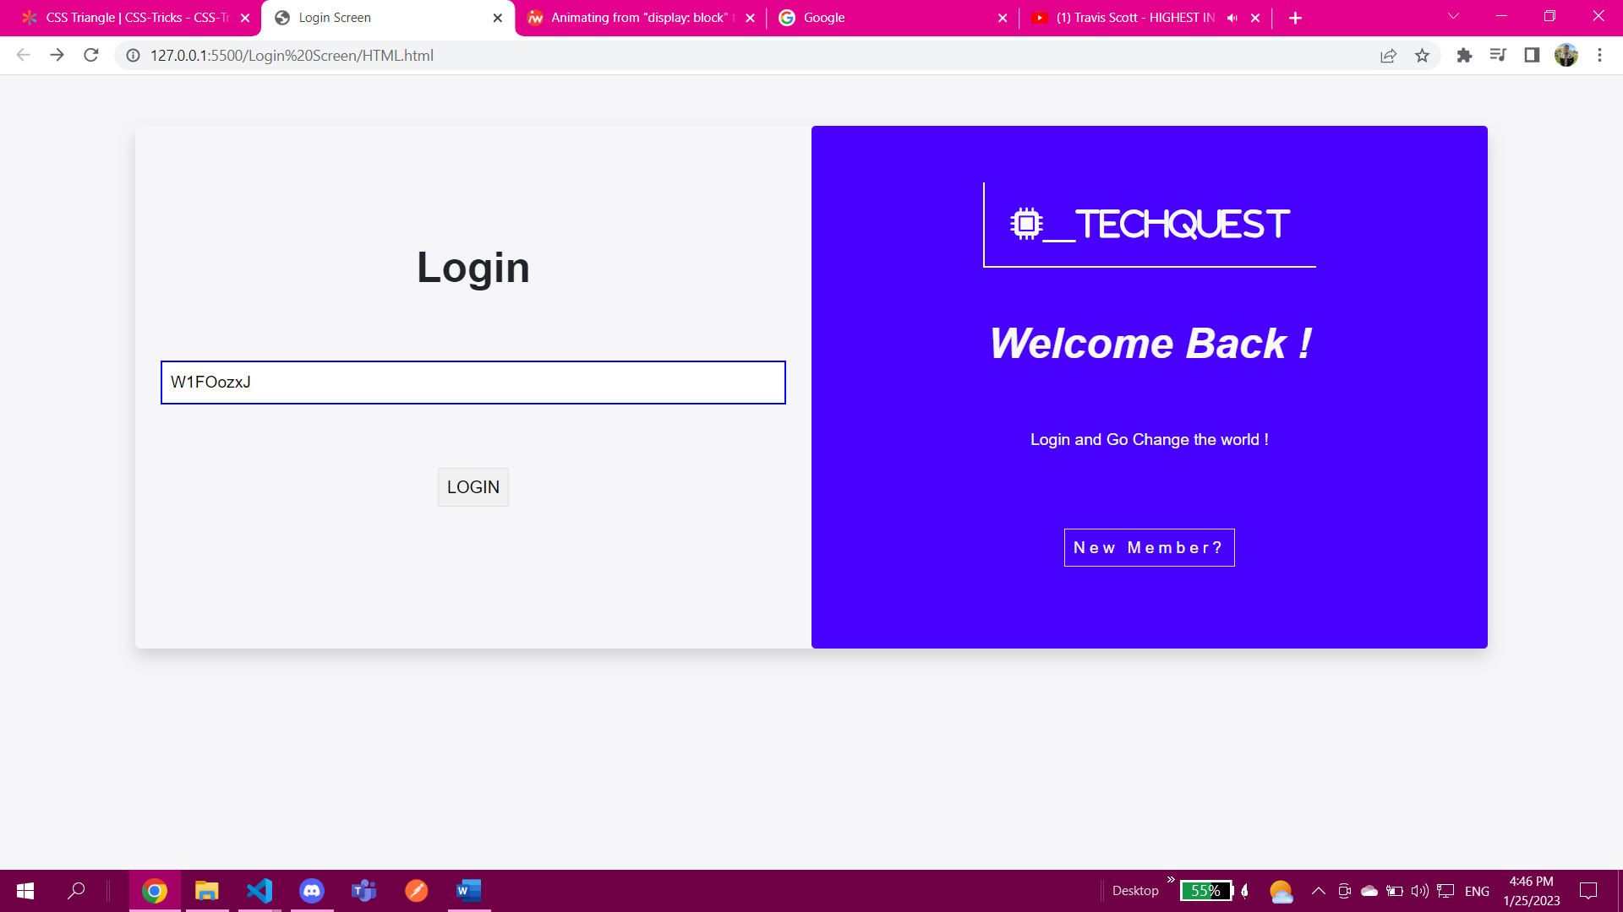

You will be directed to security page which can be also logged in to directly using another user name by the security so you’ve both options

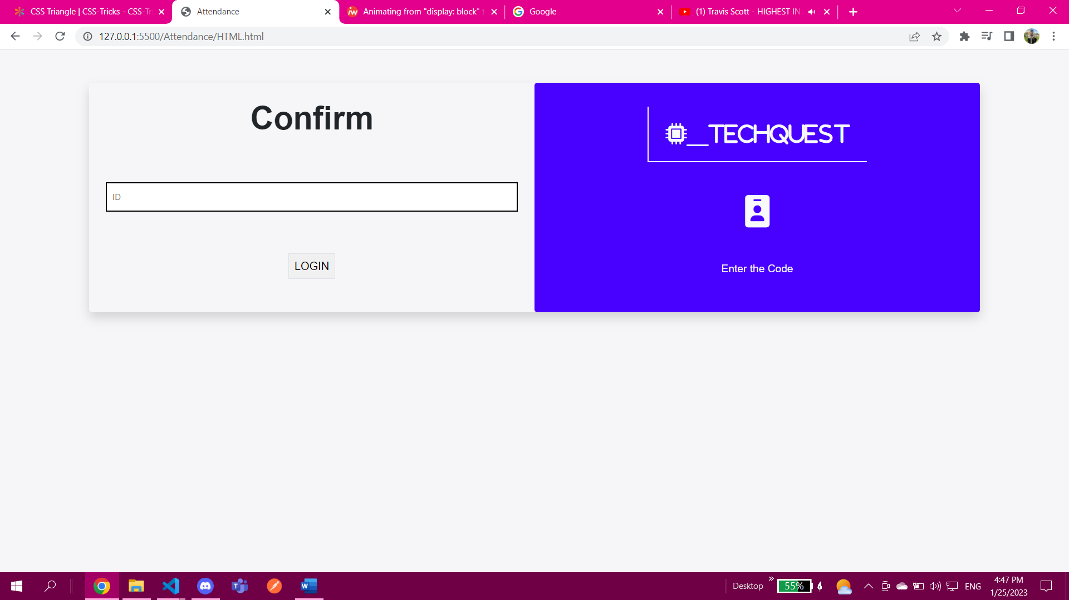

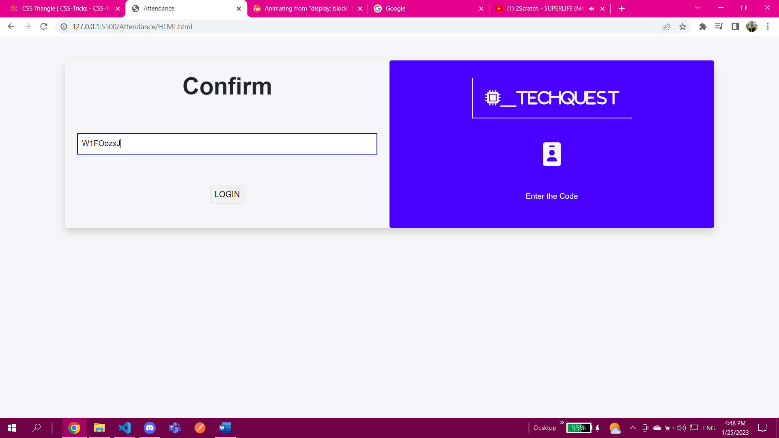

After login you will enter your page this is here is a critical point as it depends very much on the time here the time is 4:48 PM which passed 3 PM lets change it to 9AM

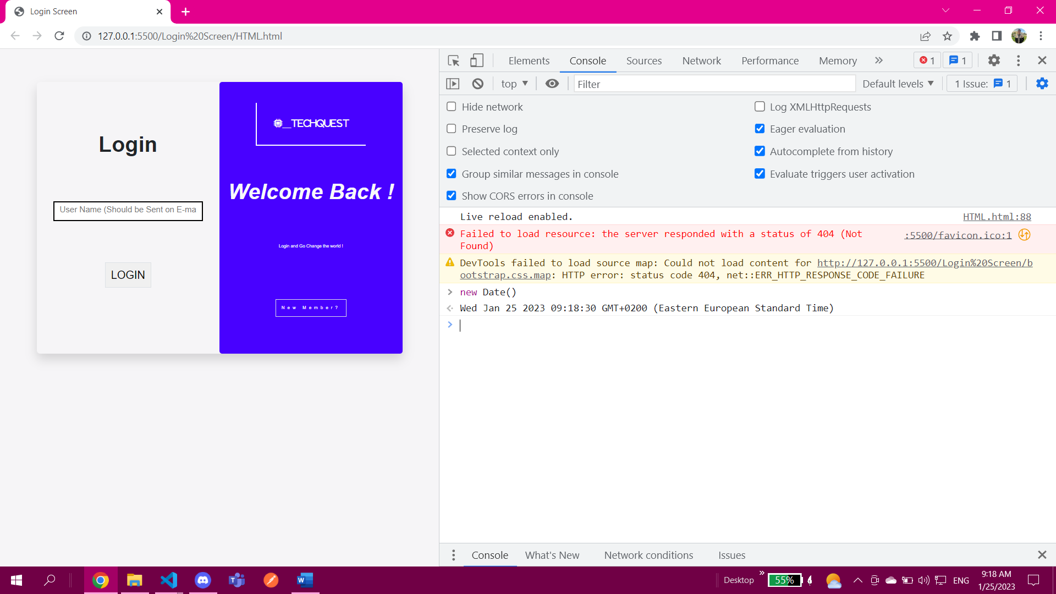

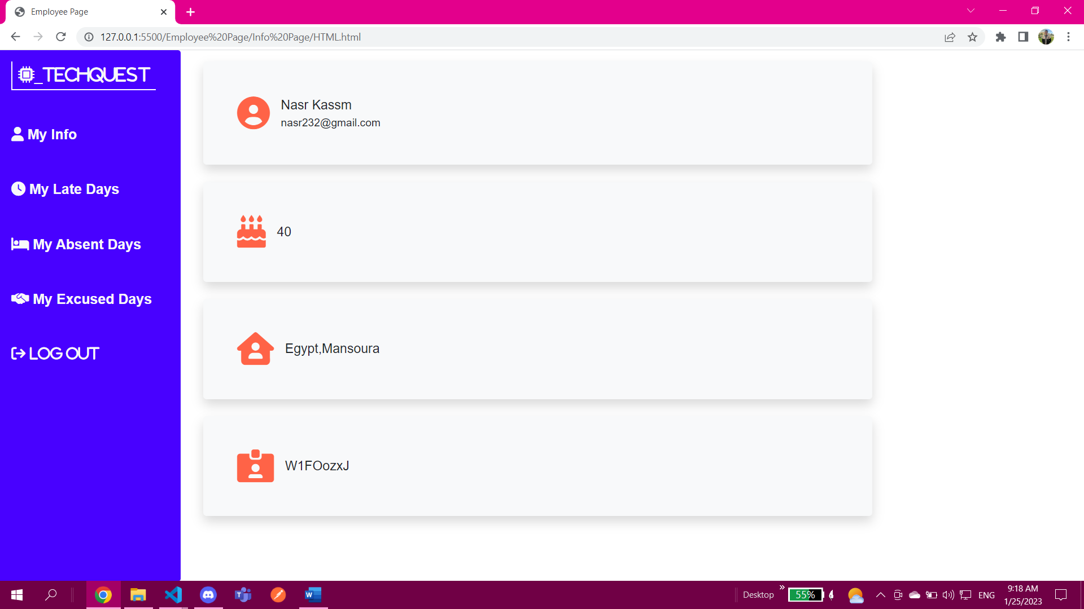

This is the employee page of course here you arrived in the permitted time which is from 9 to 9:30 after this range you will enter the late category and if you reach 10 or above then you are considred absent lets test all these

On time 

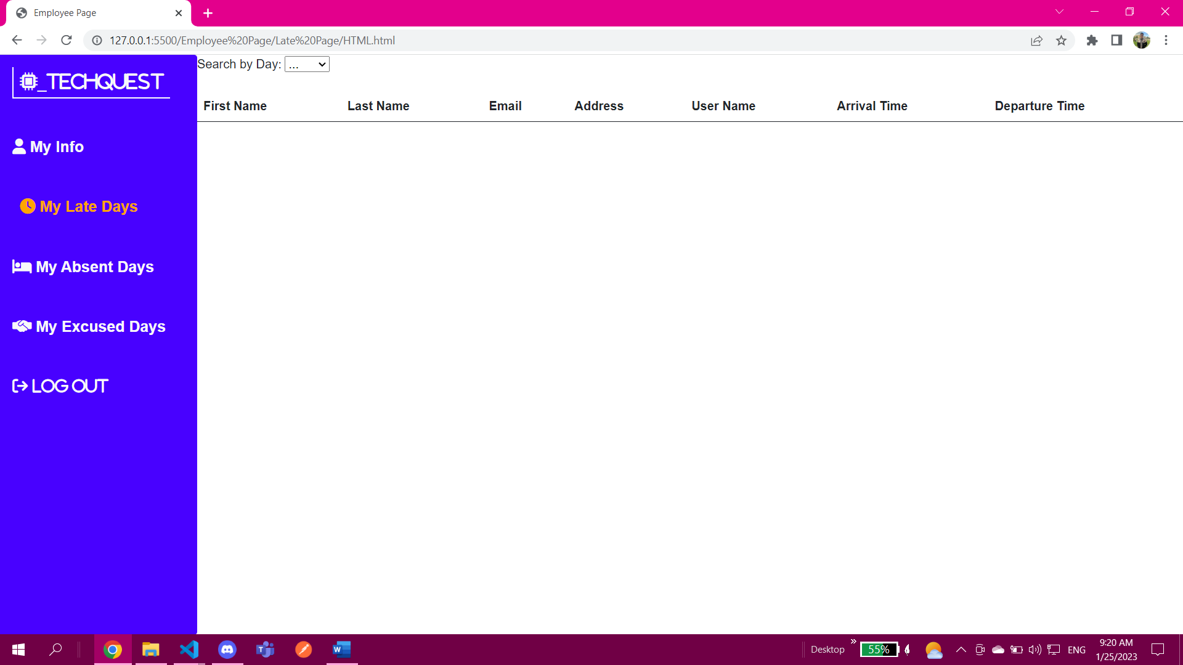

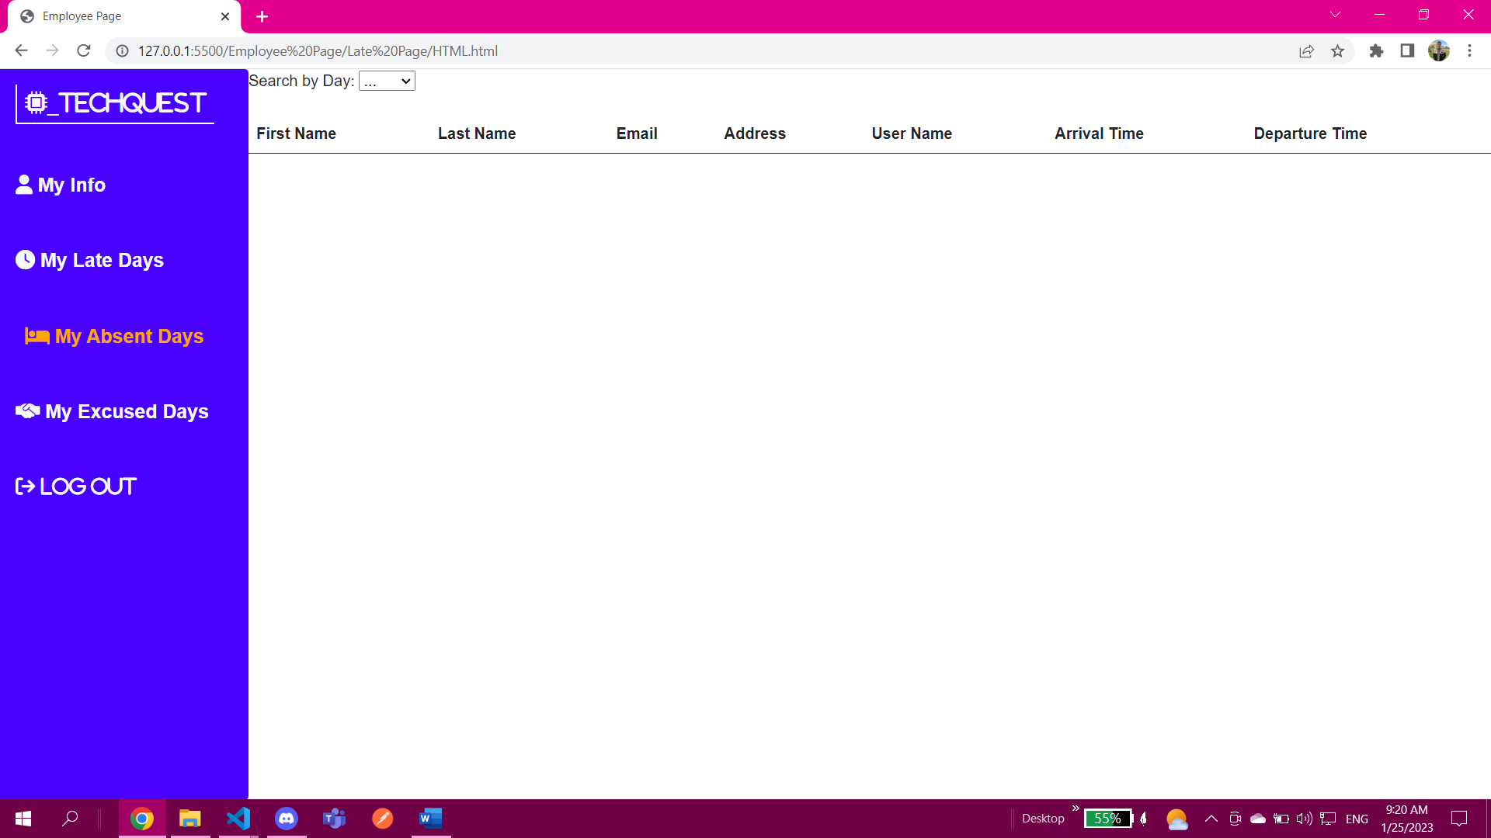

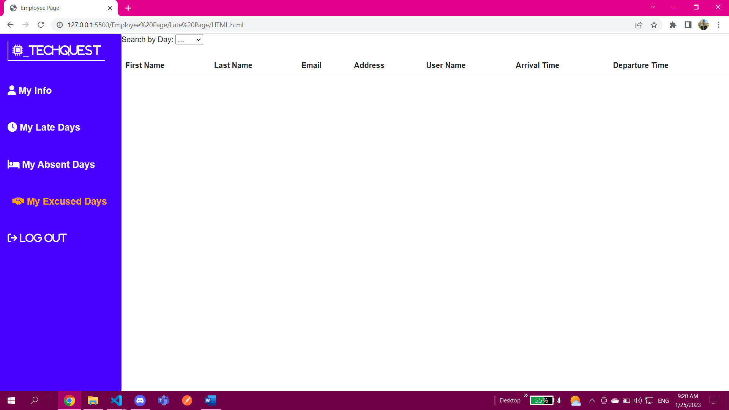

Of course all the tabs late, absent and excused are empty.

Lets say you logged out before 3PM then in this scenario you the employee will be saved in the reports tab in admin page

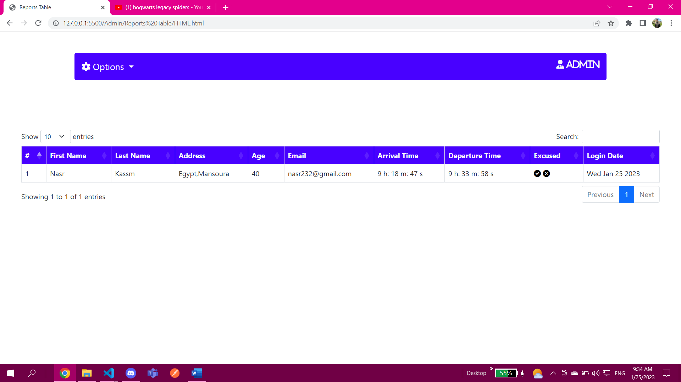

Here you can say he is excused or no if no he will be saved in violation table

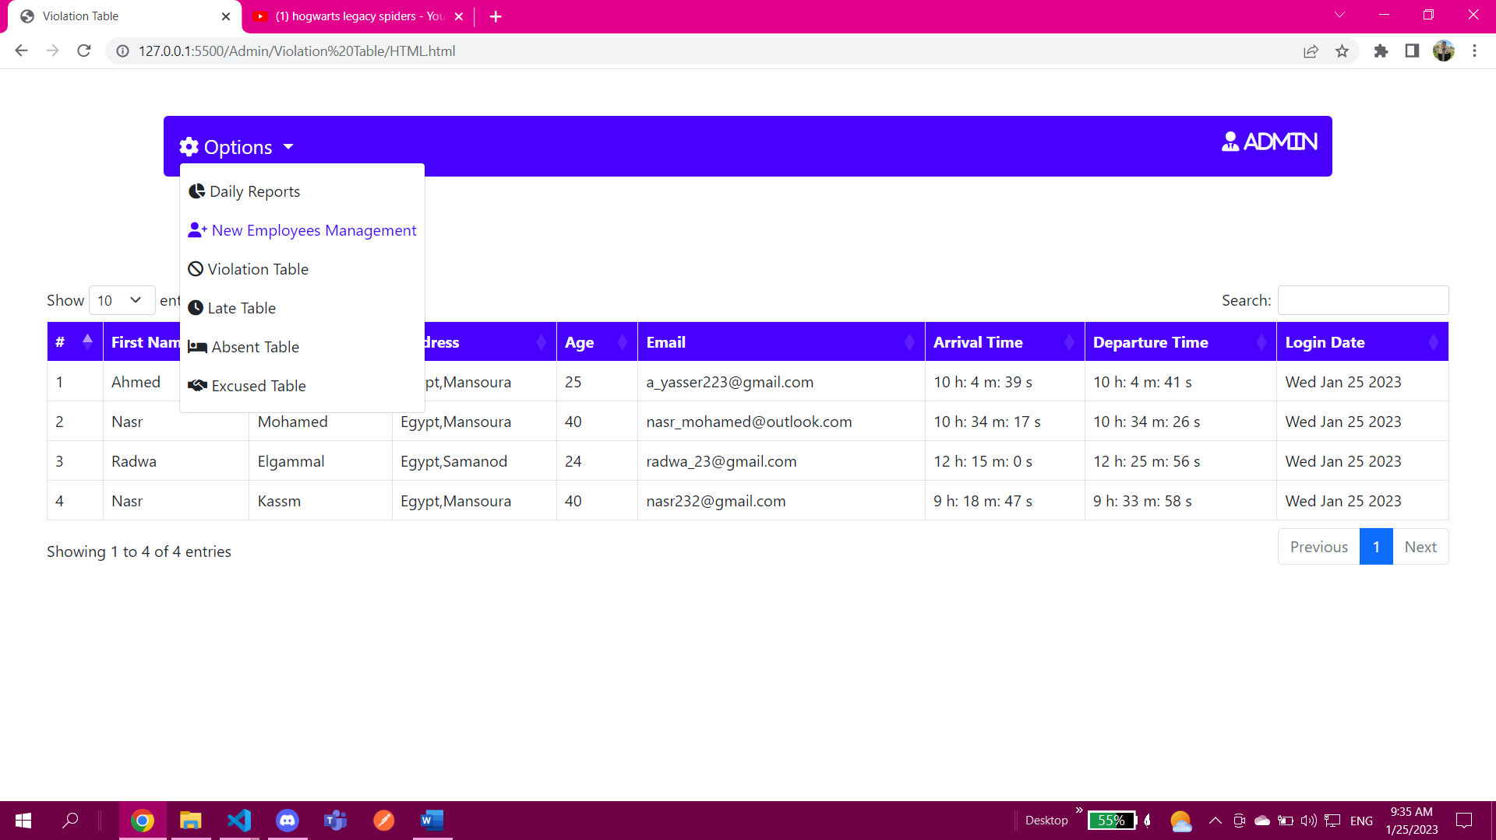

Now lets login again at 9:37 and see what happens

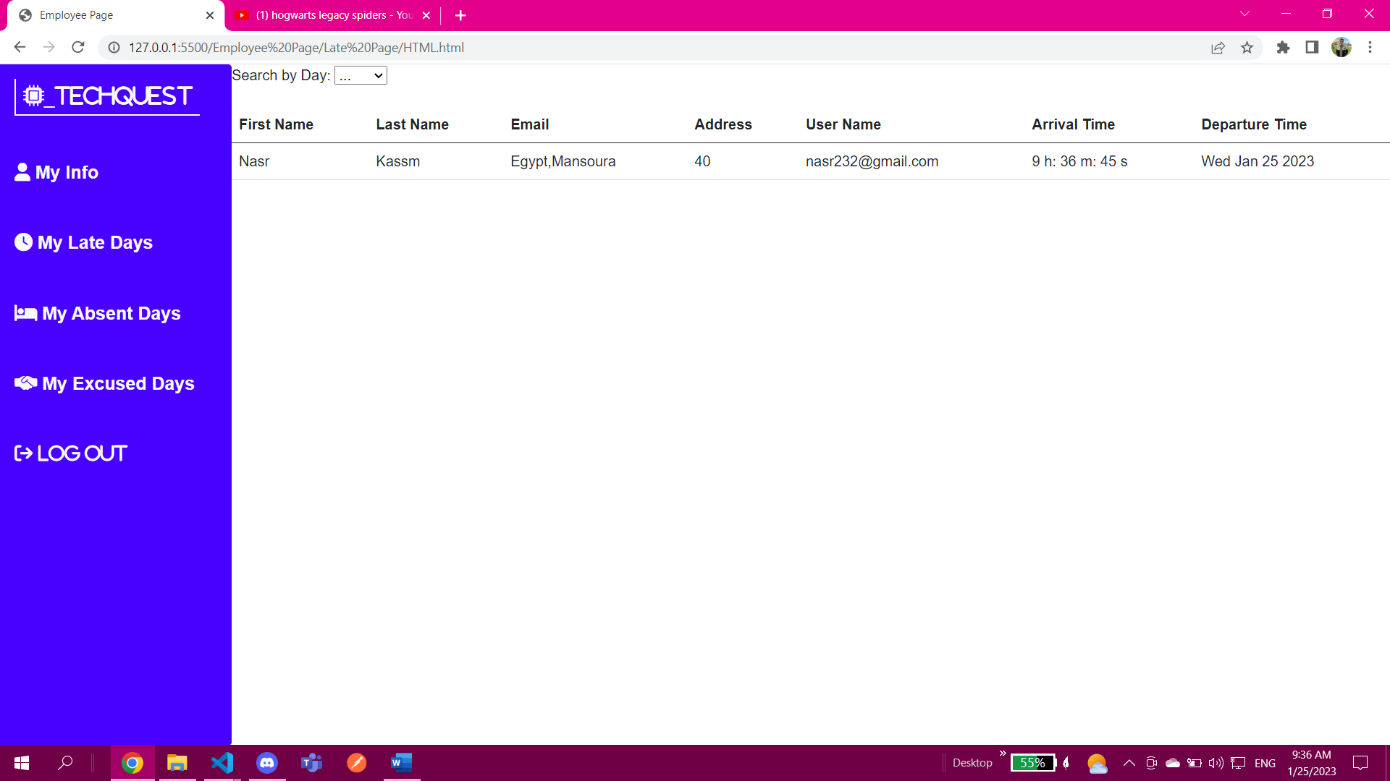

As you can he is placed inside the late tap

Now lets login again after 10AM

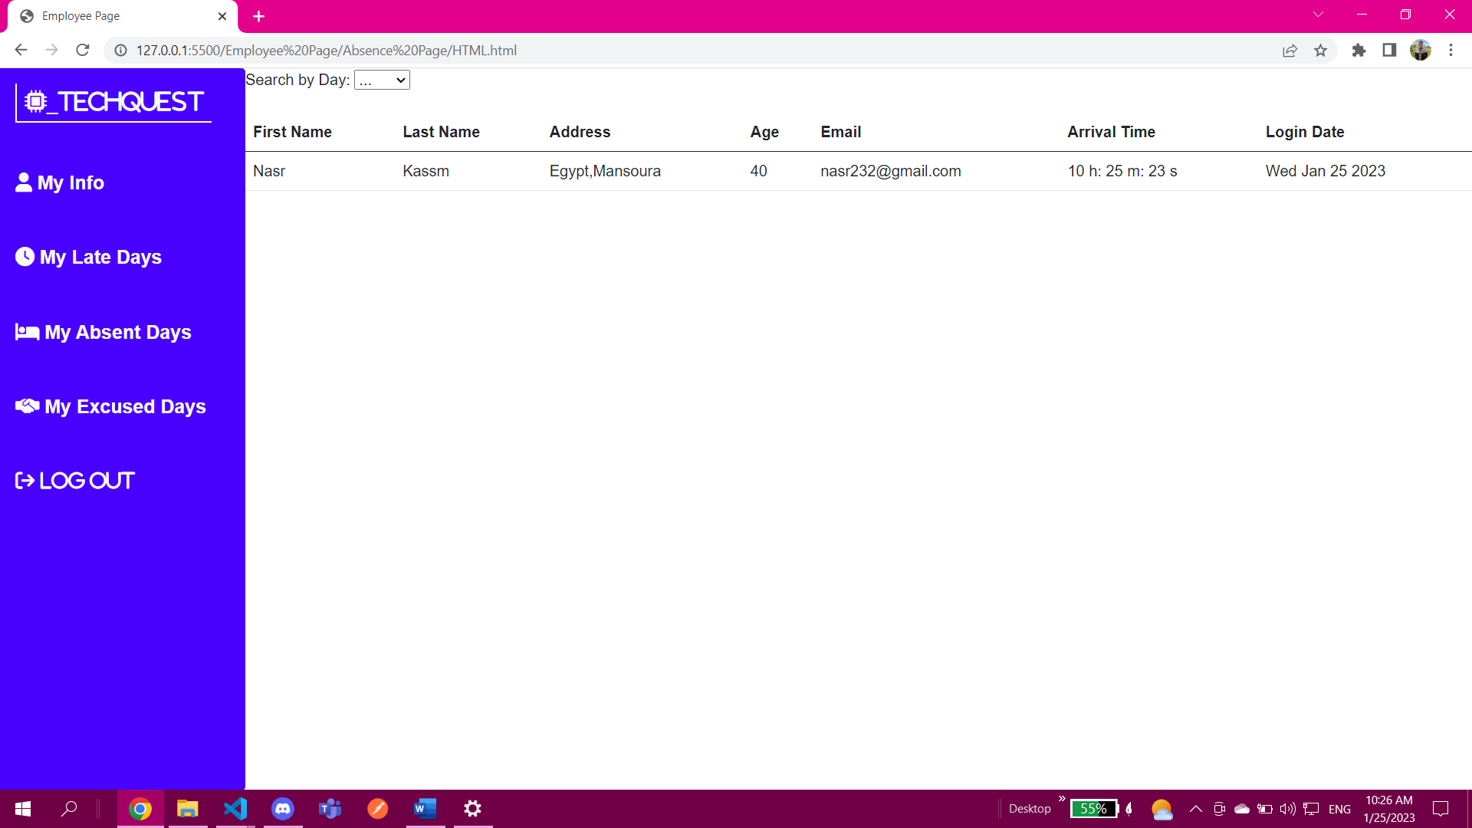

He appeared in the absent tap

Now assume you left early and you’ve got an excuse lets try it before 10 AM of course

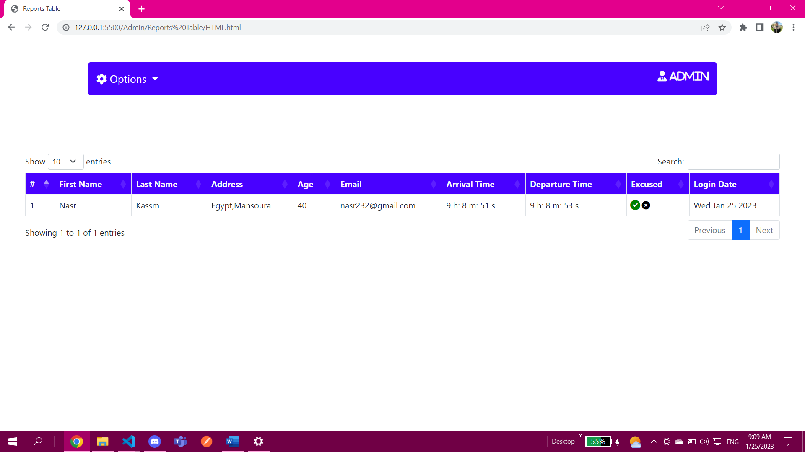

Here at excused table he can be found

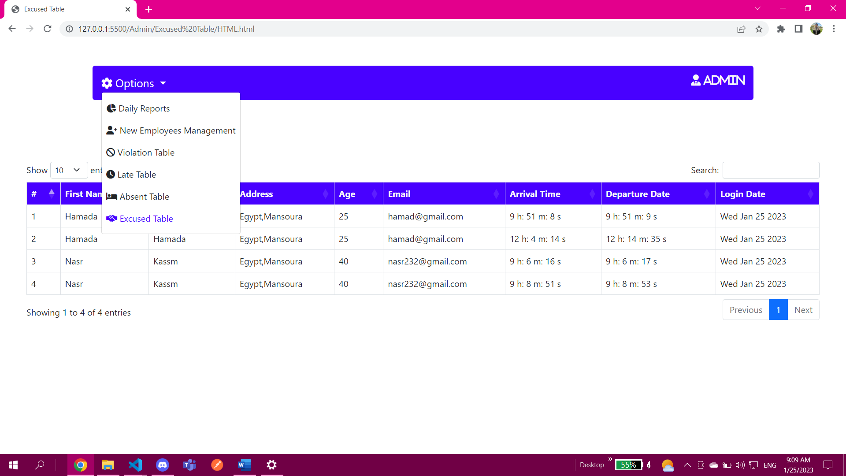

And also you can find him in the absent table from the first time

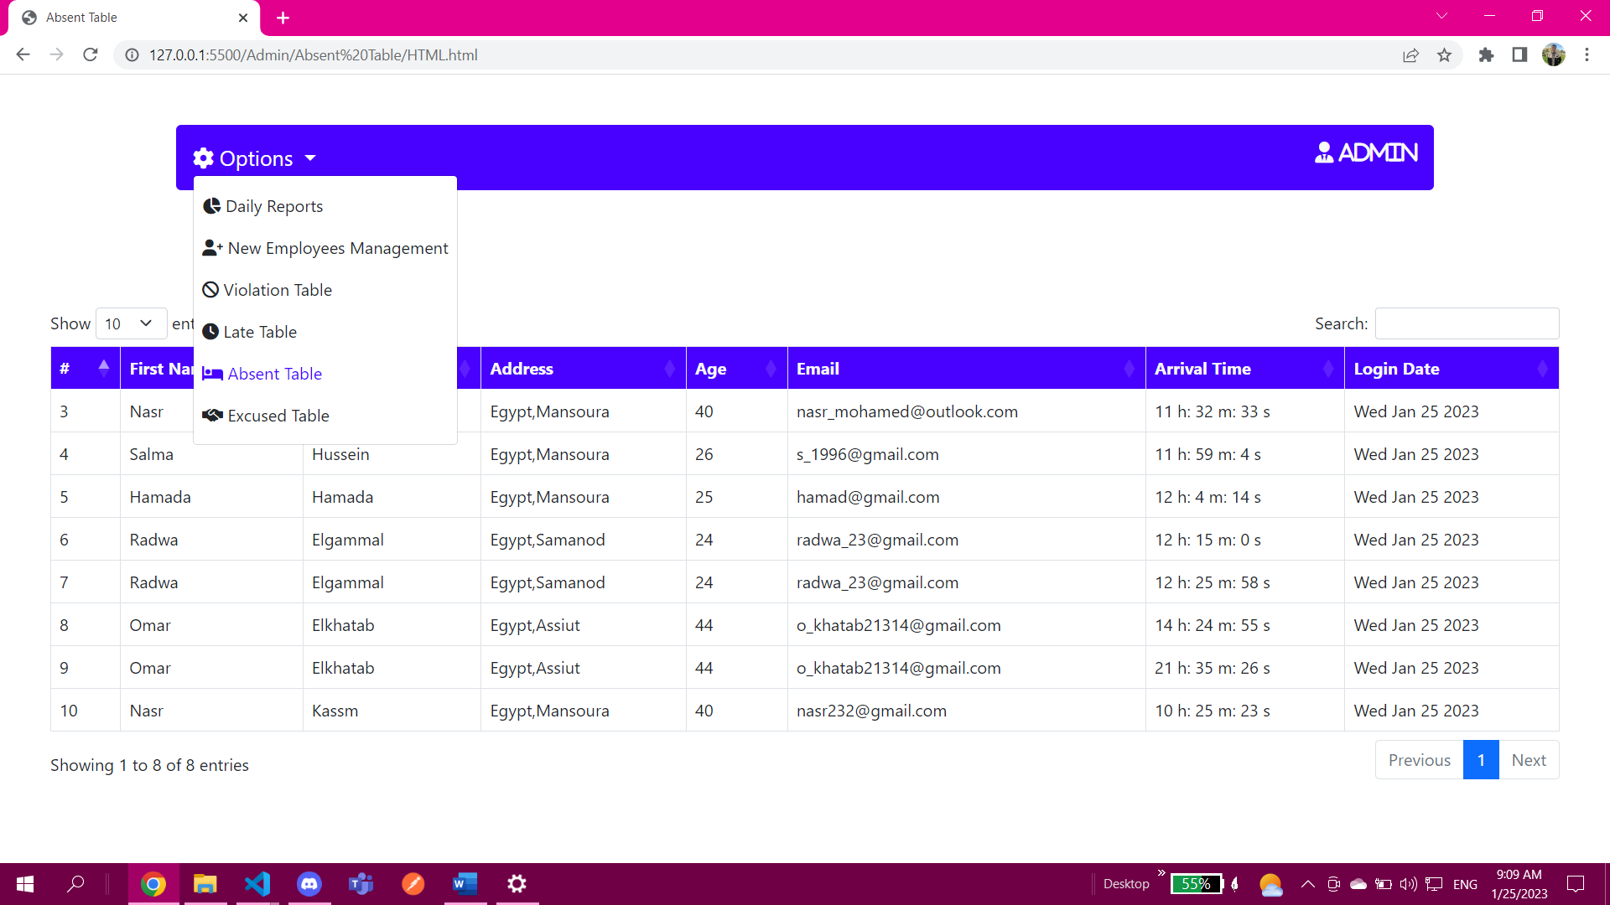

And this is it hope you’ve liked it :D <3

The issues:

1-E-mail is not sent to the user but everything in the code is written as it should be

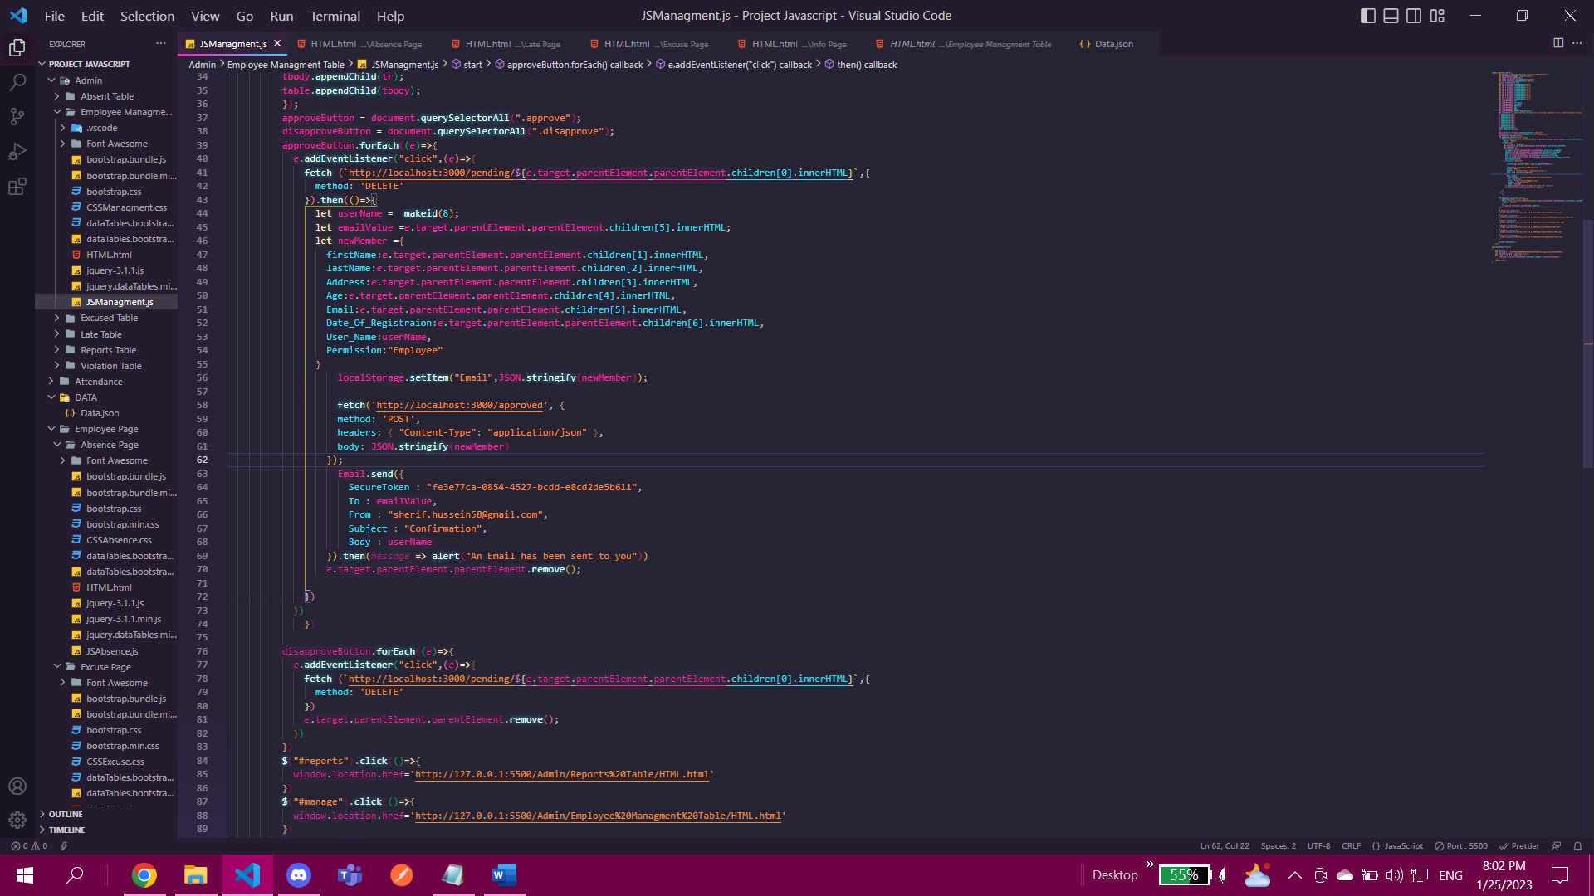

If we looked closely at this part the page after hitting confirm icon or button the page refreshes so it doesn’t get to send anything but tried on console and worked

2-After login and entering security screen when you type the user name and hit login it sometimes freezes and doesn’t login (in other words prevent default on its own) how can be solved just change the time of the computer